Week 2 First Android App

This lab exercise is fully based on the official Android tutorial, but we extend it a bit with providing more materials about some functionality.

It might take quite a long period of time (more than 4 hours) to finish all tasks for a beginner, but it’s always not easy to start for any new development. The later weeks’ exercises are somewhat based on this week’s examples, and therefore, we highly recommend that you can finish all the following tasks.

**Task 1: “Hello Android”**

We learn how to create the first android app in the Android Studio and run it on the virtual emulator and physical devices. From this example, you should understand the basic program structure about Kotlin and Jetpack compose and know some basic operations like changing background colour or adding paddings.

Please visit this link <https://developer.android.com/courses/pathways/android-basics-compose-unit-1-pathway-2> to create the first app and how to run it in the emulator or a real mobile phone. You can get help from the lab tutors or the lecture videos if some descriptions are not clear.

You may notice the function **Surface()** in the main activity. In Jetpack Compose, the Surface composable is used to provide a container with background colour, elevation, shape, and other material design properties to its children. It is a high-level component in the Material Design system and helps you create a consistent UI appearance across your app by adhering to material theming. You can leave it aside if you are new to mobile app development.

***Modifier:***

Modifiers allow you to decorate or augment a composable. Modifiers let you do these sorts of things:

1. Change the composable's size, layout, behaviour, and appearance
2. Add information, like accessibility labels
3. Process user input
4. Add high-level interactions, like making an element clickable, scrollable, draggable, or zoomable

You can visit this link <https://developer.android.com/jetpack/compose/modifiers> to understand more about the usage of modifier. Or there is another excellent [mini tutorial](https://medium.com/@anandgaur22/modifiers-in-jetpack-compose-f2bd164fb9c6) for using Modifiers.

Task 2: Build a basic layout

We learn how to build a simple app with text composables with basic layout UI and images. Please visit this link <https://developer.android.com/courses/pathways/android-basics-compose-unit-1-pathway-3> and finish the tutorial.

This is a long tutorial, and you need to finish a couple of apps. The birthday card app is the main app where you can learn a lot about the basic layout. Then, as the practices, from Activity 5, you can exercise THREE apps, compose article, task manager and compose quadrant. The solution is also provided within the tutorial. Note that the solution is variable, you can work out your own version.

It is unlikely that you can remember or be familiar with the layout immediately after the tutorial. Therefore, Google or ChatGPT might be the handy tools to use whenever you are looking for a function to change the layout.

You can also look at this [mini tutorial](https://medium.com/@esthcarelle/jetpack-compose-layouts-crafting-with-column-and-row-117d51761d63) for jetpack layouts with column and row.

Task 3: UWE contacts app

To test your study, we give a challenge that you build an UWE contacts app. This is a simple app, but it will be augmented with more views or activities later.

You need to build one view that includes an UWE logo, a contact person photo, name, email, an office location, and a phone number. The layout can be referred to the following screenshot. It is unnecessary to be exactly same, but the basic layout should be similar.

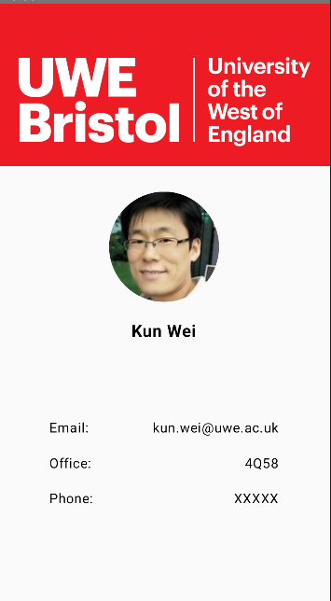

The UWE logo and the module leader’s photo can be downloaded from BB, and of course, you can use other persons’ photos.